Change user personal page:

The personal pages of all user can be change at once with the group template “Main personal user 2”. All new registered users will add to this group automatic. Therefore all registered users have a persoanl page with predefined portlets and permissions.

Attention !!!

Dont delete page at template, e.g. activities and create page with same name. This has broken my template, and I must create a new one.

Only additional pages or updates of existing pages can be changes for existing personal pages. If page will be delete at template I will not delete a existing personal pages after deselect/select member of group.

How to add new page/link:

- Control Panel
- User Groups
- Actions at “Main personal user 2”
- Manage pages
- New Page
- Add Page
- Type name for new page and commit changes with “ADD PAGE”
- Actions at “Main personal user 2”-> Assign Member
- Deselect all members → select all members

How to add portlet

- till step 4 from last howto
- “View Pages”
- a page will be popup for the template with arranged portlet and pages
- search for location where portlet be placed
- Admin - “Add Application”
- search for right portlet
- drop it to site
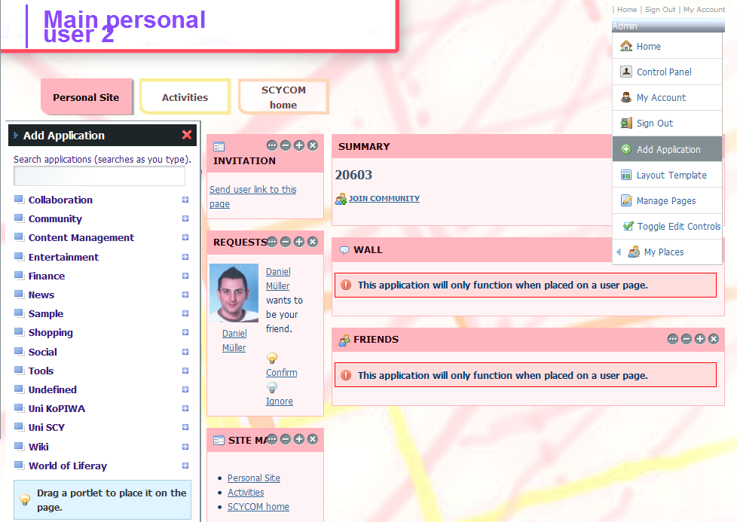
- step 8+9 from last howto

